Semester Two Examination, 2021

MODERN HISTORY

SOURCE BOOKLET

Source Set | Elective | Related question
1 | Australia 1918-1955 | 1
2 | Russia and the Soviet Union 1914 - 1945 | 1
3 | China 1935 – 1989 | 1
4 | The changing European world since 1945 | 11
5 | Australia’s engagement with Asia | 11
6 | The struggle for peace in the Middle East | 11

Set 1: Elective 1: Australia 1918-1955
Source 1
A Norman Lindsay cartoon entitled ‘The Cloud’ with Billy Hughes returning from the Paris Peace Conference in 1919. The captions read: Uncle Billy says ‘Aren’t you fond of me bringing home all these nice things to play with? Aussie replies ‘Yes. I hope I’ll like them but they are pretty heavy.’ The scrolls are labelled ‘Mandate New Guinea’ and Mandate’.
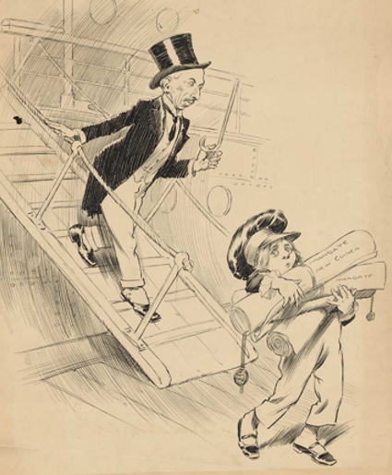

Source 2
Excerpts from an article by Australian historian Ann Moyal entitled, ‘1919: The triumph of Billy Hughes’, published on the Australian Strategic Policy Institute website on ANZAC Day 2019.
He (Hughes) publicly crossed the lofty Wilson (USA President) in an exchange seen by observers as the ‘little David facing the American Goliath’. Chided* later by Wilson in the debate on the German Pacific colonies because Australia represented only a small country of five million people, Hughes replied simply: ‘I speak for 60,000 dead.’ As the story of the confrontations spread around Paris, Hughes became something of a folk hero.
…He was equally intransigent in his demand for settlement of the fate of Germany’s territories in the Pacific. Eager initially for Australian annexation of Papua New Guinea, he accepted the compromise decision for a special mandate giving Japan administrative control of the German islands north of the equator, New Zealand the mandated territory of Samoa, and Australia administrative control (the so-called ‘999 years’) of mandated Papua New Guinea and adjacent islands.
…The Paris Peace Conference was the first major international conference at which Australia was represented independently from Britain. There, impatient of British and foreign opposition, his style spirited and unorthodox, Hughes emerged as a formidable player who took advantage of his principal delegate status to push the Australian barrow.
*chided – to voice disapproval or speak to someone severely
See next page
Source 3
Cartoon from London’s Daily Chronicle published in 1926.
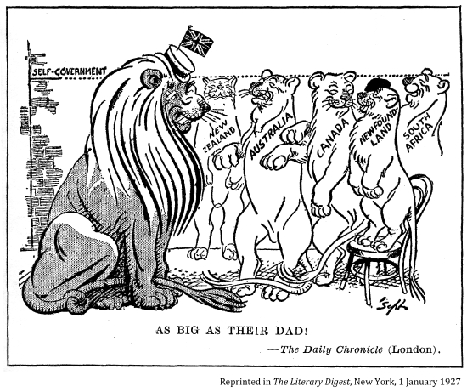

Source 4
Excerpts from Prime Minister Menzies speech at a dinner held in his honour by President Eisenhower, in New York, March 1955.

…References have been made, and very properly made to the comradeship which exists between the United States and Australia, and it is a very profound one…..I very well remember before the war….Australia was a very remote speck in the world, and this last war (WWII) seems to me to have changed all that. Too many hundreds of thousands of young Americans were in Australia, received into Australian homes, seen in their uniforms, heard of in their joint battles with Australian troops, for our countries-my country and the United States of America-to remain as merely distant communities. I venture to believe that those experiences brought about an intimacy, a sense of neighborhood, a sense of closeness, which could not have happened under any other circumstances.
…We need not pretend to ourselves the world is not today sharply divided—not divided by our will, but by the will of others-sharply divided between those who, like ourselves, believe in the free life of the individual, and those who, like the other great group in the world, believe in the disciplined service of masses of people to whom freedom is denied.

We of the Democratic world try to follow the Democratic line, but the Democratic line is not one line but three hundred, and that is something we need to have in mind, because the whole object of an aggressive, genuinely imperialistic force like world Communism is to divide and conquer.

END OF DOCUMENT SET

Set 2: Elective 2: Russia and the Soviet Union 1914 - 1945
Source 1
A cartoon by Bernard Partridge entitled ‘Who follows me for Holy Russia’s sake?’ published in Punch Magazine in September 1915.
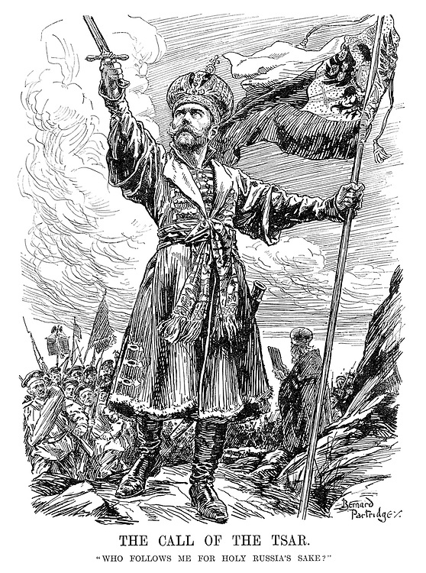

Source 2
An extract from Buchanan’s book titled ‘My Mission to Russia and Other Diplomatic Memories’, published in 1922. Buchanan, British Ambassador to Russia, writes about his meeting with Nicholas II on 12th January, 1917.
I went on to say that there was now a barrier between him and his people, and that if Russia was still united as a nation it was in opposing his present policy. The people, who have rallied so splendidly round their Sovereign on the outbreak of war, had seen how hundreds of thousands of lives had been sacrificed on account of the lack of rifles and munitions; how, owing to the incompetence of the administration, there had been a severe food crisis, and - much to my surprise, the Emperor himself added, "a breakdown of the railways". All that they wanted was a Government that would carry on the war to a victorious finish…
I next called His Majesty's attention to the attempts being made by the Germans, not only to create dissension between the Allies, but to estrange him from his people. Their agents were everywhere at work. They were pulling the strings, and were using as their unconscious tools those who were in the habit of advising His Majesty as to the choice of his Ministers. They indirectly influenced the Empress through those in her entourage, with the result that, instead of being loved, as she ought to be, Her Majesty was discredited and accused of working in German interests. The Emperor once more drew himself up and said: "I choose my Ministers myself, and do not allow anyone to influence my choice."
See next page
Source 3
A Clifford Berryman cartoon entitled ‘Awake the Russian Bear’ published in June 1918 in the Washington Star newspaper, USA.
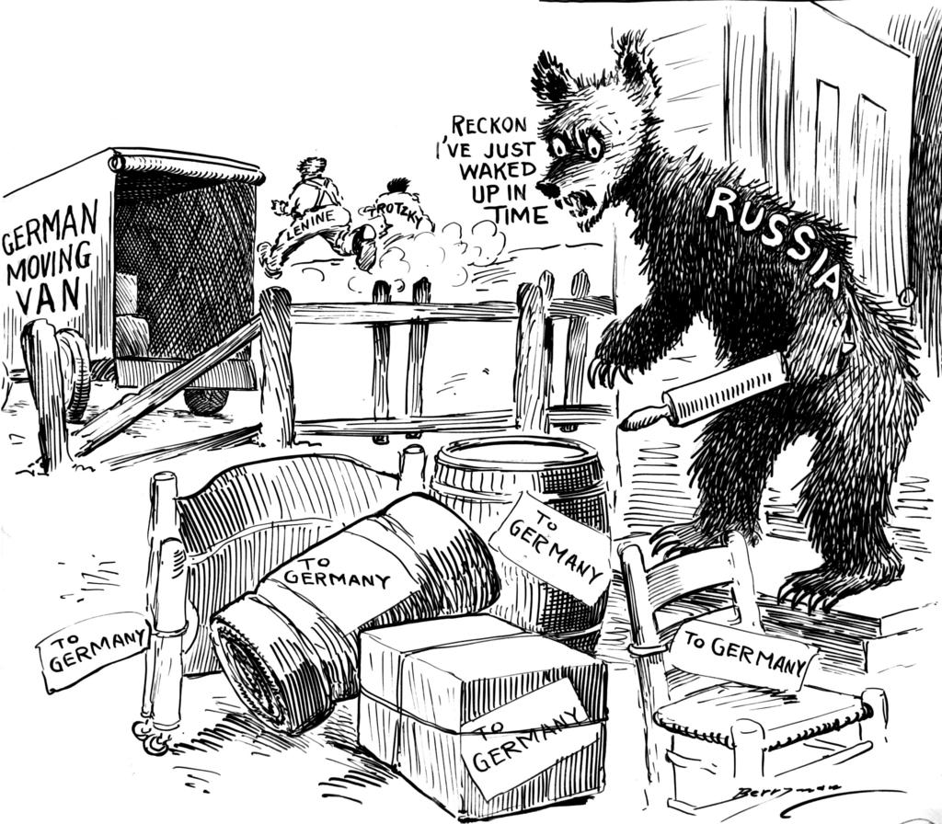

Source 4
Extract from the autobiography, ‘Khrushchev Remembers’ published in 1971. Whilst Khrushchev was Secretary of the Moscow Regional Committee he accompanied Stalin to the signing of the Nazi-Soviet Pact.
I believe the Ribbentrop-Molotov Pact of 1939 was historically inevitable, given the circumstances of the time, and that in the final analysis it was profitable for the Soviet Union. It was like a gambit in chess: if we hadn't made that move, the war would have started earlier, much to our disadvantage. It was very hard for us - as Communists, as anti-fascists - to accept the idea of joining forces with Germany. It was difficult enough for us to accept the paradox ourselves.

For their part, the Germans too were using the treaty as a manoeuvre to win time. Their idea was to divide and conquer the nations which had united against Germany in World War I and which might unite against Germany again. Hitler wanted to deal with his adversaries’ one at a time. He was convinced that Germany had been defeated in World War I because they tried to fight on two fronts at once. The treaty he signed with us was his way of trying to limit the coming war to one front.

END OF DOCUMENT SET
Set 3: Elective 3: China 1935 – 1989
Source 1
A poster produced in China in October, 1953. It reads ‘The Soviet Union is our example’ with a one of Moscow’s Seven Sisters buildings with Stalin’s portrait on the front, in the background of the Chinese worker.
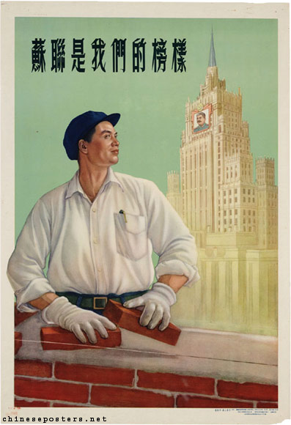

Source 2
Extract from ‘Stalin’s role in the Communist victory in China’ by Peter S.H. Tang published in The American Slavic and East European Review, Vol.13 No.3, October 1954

Mao Tse-Tung’s 1949 victory has frequently been credited to Mao’s ability as an astute peasant revolutionary rather than to his standing as an orthodox Communist leader. The record suggests that Stalin’s development of tactics for Mao had more influence on the course of events than is commonly supposed.

… In developing a Communist revolutionary strategy for China, Stalin tried first of all to determine the character of a Chinese revolution. In accordance with the principles of Leninism, Stalin drew a clear distinction between two types of Communist revolution – “the revolutions in the imperialist countries oppressing other peoples,” such as Russia, and the “the revolutions in the colonial and dependent countries suffering imperialist oppression,” such as China. Stalin’s consideration of the two possible approaches to the same Communist objective indicates that there was no basis in fact for those wishful thinkers who assumed that Mao’s brand of Communism was different from Leninism-Stalinism simply because the revolution took place in China in a manner unlike that of Russia.

See next page
Source 3
Cartoon by Mort Drucker entitled ‘Ping Pong Diplomacy’, published on July 26, 1971 in Time Magazine, USA. It followed the announcement of Nixon’s plans to travel to China.

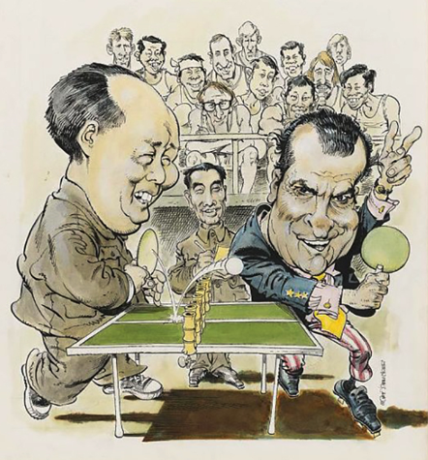

Source 4
Excerpt from the article ‘Aims of Reagan’s China visit thwarted’ by John Ota first published in May, 1984 and posted on www.marxists.org website.
Visions of Ronald Reagan, the diehard anti-Communist, standing on the Great Wall and shaking hands cordially with his Communist hosts may make some people more hopeful about peace in the world. However, this trip, in reality demonstrates, nothing very positive about Reagan and peace. Reagan rudely attempted to use his China trip to further his own hegemonic and aggressive rivalry with the Soviet Union and violated the hospitality extended to him by launching into totally offensive lectures about God, capitalism and the family.

… Perhaps the only positive hope for peace coming out of this trip is the stance taken by the Chinese. The Chinese, far from advancing the cause of censorship, actually aided world peace by deleting from Reagan’s speeches, for publication in the Chinese press, the most unsuitable attacks on the Soviet Union, making it clear that the Chinese oppose superpower rivalry and would not be drawn into its midst.

END OF DOCUMENT SET
Set 4: Elective 1: The changing European world since 1945

Source 1

Cartoon on Soviet foreign policy and the establishment of NATO, produced in April 1949, by British cartoonist Leslie Gilbert Illingworth. It explores the role played by Soviet leader Joseph Stalin in the establishment of the North Atlantic Treaty Organisation (NATO).
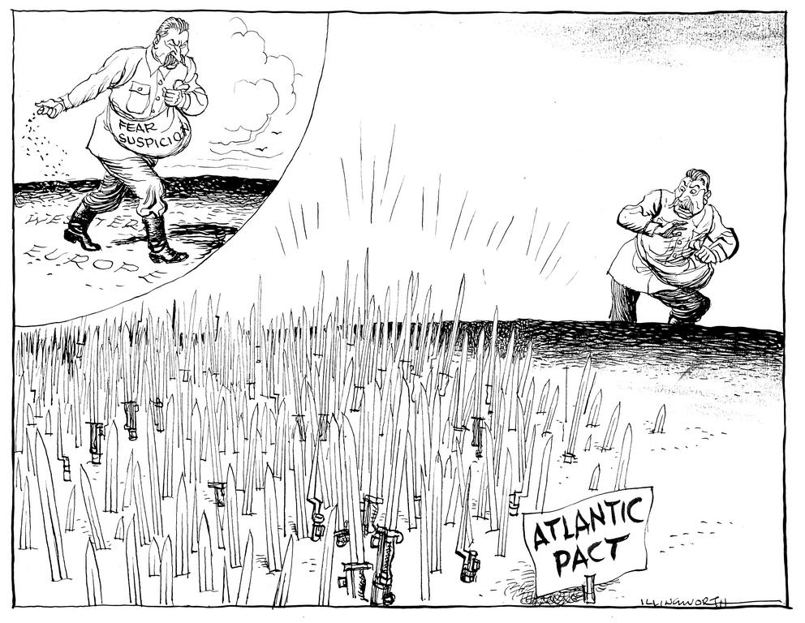

Source 2
Excerpts from NATO’s website entitled ‘A short history of NATO’, published 2001.

It is often said that the North Atlantic Treaty Organization was founded in response to the threat posed by the Soviet Union. This is only partially true. In fact, the Alliance’s creation was part of a broader effort to serve three purposes: deterring Soviet expansionism, forbidding the revival of nationalist militarism in Europe through a strong North American presence on the continent, and encouraging European political integration…

Communists aided by the Soviet Union were threatening elected governments across Europe. …Fortunately, by then the United States had turned its back on its traditional policy of diplomatic isolationism. Aid provided through the US-funded Marshall (Plan) …fostered a degree of economic stabilisation. European states still needed confidence in their security, however, before they would begin talking and trading with each other. Military cooperation, and the security it would bring, would have to develop in parallel with economic and political progress.

….With this in mind, several Western European democracies came together to implement various projects for greater military cooperation and collective defence …it was determined that only a truly transatlantic security agreement could deter Soviet aggression while simultaneously preventing the revival of European militarism and laying the groundwork for political integration.

Accordingly, after much discussion and debate, the North Atlantic Treaty was signed on 4 April, 1949.

See next page
Source 3
A cartoon by Alexander Klas produced circa 1999, during NATO’s involvement in former Yugoslavia. He originated from Serbia, having over 30 000 of his cartoons published in national and international newspapers and magazines.

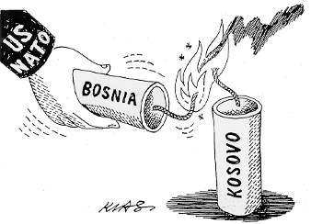

Source 4
Excerpt from George Kennan’s ‘A Fateful Error’ article from the New York Times, February 5 1997. Kennan famously sent the ‘Long Telegram’ to America whilst working in Moscow in 1947.
Why, with all the hopeful possibilities engendered by the end of the Cold War, should East-West relations become cantered on the question of who would be allied with whom and, by implication, against whom in some fanciful, totally unforeseeable and most improbable future military conflict?
Bluntly stated … expanding NATO would be the most fateful error of American policy in the entire post-Cold War era. Such a decision may be expected to inflame the nationalistic, anti-Western and militaristic tendencies in Russian opinion; to have an adverse effect on the development of Russian democracy; to restore the atmosphere of the cold war to East-West relations, and to impel Russian foreign policy in directions decidedly not to our liking…

END OF DOCUMENT SET
Set 5: Elective 2: Australia’s engagement with Asia
Source 1
A Gordon Minhinnick cartoon titled ‘The Strong Stand’ from the New Zealand Herald, 17 April 1964. It considers military intervention in Vietnam with Australia and New Zealand (Holyoake) being pushed by Uncle Sam dressed as an USA soldier.
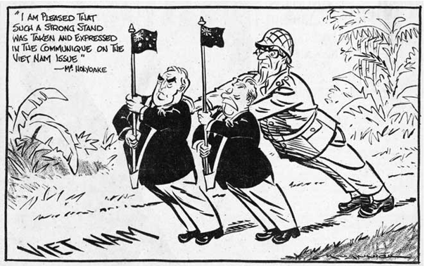

Source 2
Excerpts from a speech delivered by Arthur Calwell, ALP Leader of the Opposition in the House of Representatives on May 4, 1965 regarding the Menzies government’s commitment of troops to South Vietnam.

….On behalf of all my colleagues of Her Majesty’s Opposition, I say that we oppose the Government’s decision to send 800 men to fight in Vietnam. We oppose it firmly and completely.

We regret the necessity that has come about. We regret that as a result of the Government’s action it has come about. It is not our desire, when servicemen are about to be sent to distant battlefields, and when war, cruel, costly and interminable, stares us in the face, that the nation should be divided. I say, we oppose this decision firmly and completely.

We do not think it is a wise decision. We do not think it is a timely decision. We do not think it is a right decision. We do not think it will help the fight against Communism. On the contrary, we believe it will harm that fight in the long term. We do not believe it will promote the welfare of the people of Vietnam. On the contrary, we believe it will prolong and deepen the suffering of that unhappy people so that Australia’s very name may become a term of reproach among them. We do not believe that it represents a wise or even intelligent response to the challenge of Chinese power. On the contrary, we believe it mistakes entirely the nature of that power, and that it materially assists China in her subversive aims.

See next page
Source 3
A Geoff Hook cartoon published in Melbourne’s Sunday Herald newspaper, 18 July 1967; showing USA President Johnson with Australian Prime Minister Harold Holt.
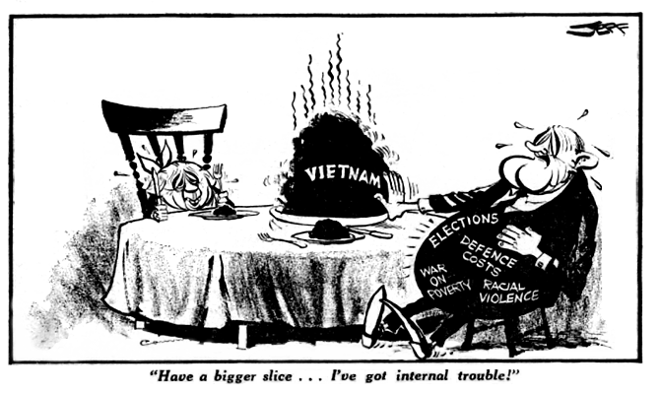

Source 4
Excerpt from Greg Sheridan’s article ‘Malcolm Fraser was no saint for Vietnamese refugees’, published in The Australian, March 26, 2015, one week after the death of Fraser.
One prime minister issued a stern warning to boatpeople that they might be forcibly sent back to their points of departure. He repeatedly authorised his immigration minister to describe them as economic migrants, not genuine refugees. Which prime minister? Malcolm Fraser.

Eventually Australia accepted a substantial number of Vietnamese, who have been magnificent migrants. But the history is utterly shrouded in mythology. …In the end, Fraser did accept a substantial number of Vietnamese and deserves credit. Politicians deserve credit for doing the right thing even if they do it late and for the wrong reasons. But he was dragged to the right decision unwillingly.

In the 7½ years Fraser was PM he accepted more than 50,000 Vietnamese. Of these only 2000 arrived directly by boat. The rest were processed in refugee camps in Southeast Asia. Fraser was the father of offshore processing.

In his memoirs and in his countless paeans* of praise to himself on this issue, Fraser claimed he was completely relaxed about unauthorised boat arrivals and courageously led the moral charge to resettle refugees. This is just not true. Though a strident anti-communist, he felt little solidarity with the anti-communist Vietnamese. Ultimately we took a substantial number of Vietnamese, on a per capita basis more than anyone else, though still a small fraction of the numbers the US took. After the fact, this rightly became a matter of pride for the Liberal Party. We did it mainly because of US pressure. You won’t read that in a politician’s memoirs.

*paeans – songs of praise
END OF DOCUMENT SET
Set 6: Elective 3: The struggle for peace in the Middle East

Source 1
A cartoon by Illingworth, published in ‘The Daily Mail’ London, May 10, 1948. The soldier is watching the clock countdown to the expiration of the British mandate in Israel, whilst Stalin (USSR) and Truman (USA) peer in through the window.
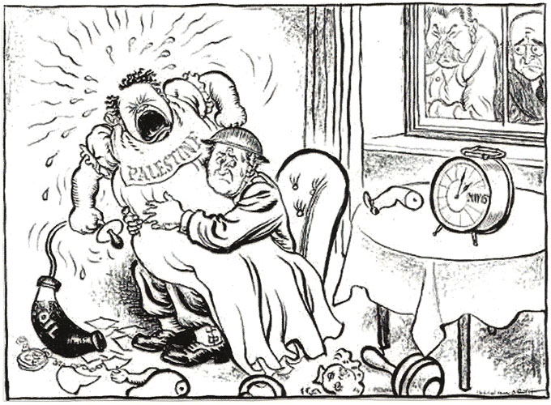

Source 2
An extract from ‘What did the British ever do for Israel? by Ian Westerman, a retired British army officer living in Herzliya, Israel. The article appeared in the Opinion section of Haaretz, an independent daily Israeli newspaper in June, 2018.
In Israel, the British Mandate is not always remembered with affection, perhaps for good reason. After all, it was hardly a philanthropic regime, and it was, at times, callous.
However, despite the legitimate criticisms, if it weren’t for the Mandate, the state of Israel would not be celebrating its 70th birthday this year, and celebrating its evolution into a successful and prosperous nation.… On May 14, 1948, the State of Israel appeared on the international scene, as if from nowhere, complete and fully functioning. More than that, from day one it was not only able to suppress an indigenous Arab population intent on seeing it stillborn, but it simultaneously fought a war with its neighboring states - and comprehensively defeated them.
What really matters is that the mechanism of the Mandate ensured that for 20 critical years, the Yishuv did not have to deal with the onerous task of actually running a state, and covered key responsibilities such as law enforcement, foreign policy, and balancing the national budget.
This freedom provided the headroom needed for the Yishuv leadership to create an independent and autonomous Jewish government-in-waiting - and they seized it.
The creditable legacy the British left, unfashionable though it is to recall, included a much admired legal system, a vastly improved infrastructure, and the concept of a professional civil service.
See next page
Source 3
A cartoon published in the Chicago Sun-Times in 1988 during the first Intifada. The drawing shows an Israeli Defense Forces solider telling a Palestinian man ‘As underdog I’ve got seniority.’
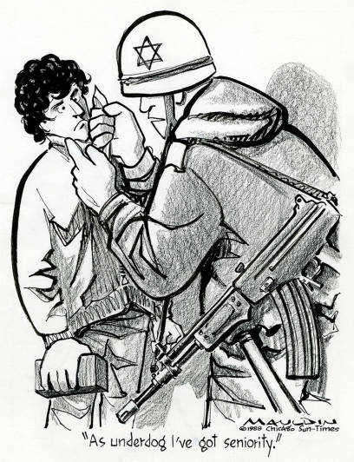

Source 4
An excerpt from ‘The Passing of Yitzhak Rabin, whose ‘Iron Fist’ fuelled the Intifada’ by Stephen J. Sosebee. His ‘Special Report’ was published in the Washington Report on Middle East Affairs in October 1990.

The intifada has ensured that Yitzhak Rabin's mark in history will be as the man who tried but failed to crush a civilian uprising with overwhelming military force. During Rabin's 28-month effort, the IDF recorded the following statistics: Over 800 Palestinian civilians shot, gassed or beaten to death; at least another 60,000 injured; over 400 homes destroyed; over 90 people deported from their homeland without trial; thousands of dunums of Arab land confiscated; the closure of all universities; the torture deaths of more than a dozen political prisoners; the closure of all West Bank schools for over a year; the forced separation of over 250 families; and the detention of nearly 10,000 people without trial. (These figures do not include Palestinians killed by Jewish settlers, or other deaths and woundings not recorded or admitted by the Israeli Defense Forces.) It is important also to remember that the Palestinian population of the West Bank and Gaza Strip is only about 1.7 million people.

The "iron fist" of Yitzhak Rabin in the occupied territories did great damage to any future possibilities of peaceful coexistence in the Middle East. By demanding a "correction" of the Palestinian "problem," the intifada both created unprecedented opportunities for negotiations and recognition, and a collapse of the coalition government. Being to some extent responsible for creating many of the conditions that gave birth to the uprising, Rabin is, in effect, a victim of his own monster. This is almost certainly how history will remember him.

END OF DOCUMENT SET
ACKNOWLEDGEMENTS

Set One Australia 1918–1955

Source 1 A Norman Lindsay cartoon entitled ‘The Cloud’ of Billy Hughes returning from the Paris Peace Conference in 1919.
Retrieved from Versailles Treaty | National Museum of Australia (nma.gov.au)

Source 2 Excerpts from an article by Australian historian Ann Moyal entitled, ‘1919: The triumph of Billy Hughes’, published on the Australian Strategic Policy Institute website on ANZAC Day 2019.
Retrieved from 1919: The triumph of Billy Hughes | The Strategist (aspistrategist.org.au)
Source 3 Cartoon from London’s Daily Chronicle published in 1926
Retrieved from Begbie Contest Society - Colony to Nation

Source 4 Excerpts from Prime Minister Menzies speech at a dinner held in his honour by President Eisenhower, USA in New York, March 1955.
Retrieved from https://pmtranscripts.pmc.gov.au/release/transcript-27

Set Two Russia and the Soviet Union 1914–1945

Source 1 A cartoon by Bernard Partridge entitled ‘Who follows me for Holy Russia’s sake?’ published in Punch Magazine in September 1915.
Retrieved from https://punch.photoshelter.com/image/I0000sz71WcjvJRw

Source 2 An extract from Buchanan’s book titled ‘My Mission to Russia and Other Diplomatic Memories’, published in 1922. Buchanan, British Ambassador to Russia, writes about his meeting with Nicholas II on 12th January, 1917.
Retrieved from https://spartacus-educational.com/FWWtsar.htm

Source 3 A Clifford Berryman cartoon entitled ‘Awake the Russian Bear’ published in June 1918 in the Washington Star newspaper, USA.
Retrieved from berryman Russia bear cartoon - Bing images

Source 4 Extract from the autobiography, Khrushchev Remembers published in 1971. Whilst Khrushchev secretary of the Moscow Regional Committee he was with Stalin when he signed the Nazi-Soviet Pact.
Retrieved from https://spartacus-educational.com/RUSnazipact.htm

Set 3: Elective 3: China 1935 – 1989
Source 1 A poster produced in China in October, 1953. It reads ‘The Soviet Union is our example’ with a one of Moscow’s Seven Sisters buildings with Stalin’s portrait emboldened on the front in the background of the Chinese worker.
Retreived from https://chineseposters.net/posters/e11-992

Source 2 Extract from ‘Stalin’s role in the Communist victory in China’ by Peter S.H. Tang published in The American Slavic and East European Review, Vol.13 No.3, October 1954
Retrieved from https://www.jstor.org/stable/2491819

Source 3 Cartoon by Mort Drucker entitled ‘Ping Pong Diplomacy’, published on July 26, 1971 in Time Magazine. It followed the announcement of Nixon’s plans to travel to China.
Retrieved from https://www.fcchk.org/correspondent/50-years-on-the-table-tennis-match-that-changed-the-world/

Source 4 Excerpt from the article ‘Aims of Reagan’s China visit thwarted’ by John Ota first published in May, 1984 and posted on www.marxists.org website.
Retrieved from www.marxists.org
Set 4: Elective 1: The changing European world since 1945

Source 1 Cartoon by Illingworth on Soviet foreign policy and the establishment of NATO, produced on 4 April 1949, by British cartoonist Leslie Gilbert Illingworth.
Retrieved from www.cvce.eu

Source 2 Excerpts from NATO’s website entitled ‘A short history of NATO’, published 2001.

Retrieved from https://www.nato.int/cps/en/natohq/declassified_139339.htm

Source 3 A cartoon by Alexander Klas produced circa 1999, during NATO’s involvement in former Yugoslavia. He originated from Serbia, having over 30 000 of his cartoons published in national and international newspapers and magazines.
Retrived from https://images.app.goo.gl/fHnpuqKSbr7ioE8s6

Source 4 Excerpt from George Kennan’s ‘A Fateful Error’ article from the New York Times on February 5 1997. Kennan famously sent the Long Telegram to Truman in 1947.
Retrieved from https://comw.org/pda/george-kennan-on-nato-expansion/

Set 5: Elective 2: Australia’s engagement with Asia

Source 1 A Gordon Minhinnick cartoon titled ‘The Strong Stand’ from the New Zealand Herald on 17 April 1964. It considers military intervention in Vietnam with Australia and New Zealand (Holyoake) being pushed by Uncle Sam dressed as an USA soldier.
Retreived from Minhinnick on intervention in Vietnam, 1964 – Cartooning – Te Ara Encyclopedia of New Zealand

Source 2 Excepts from a speech delivered by Arthur Calwell, ALP Leader of the Opposition in the House of Representatives on May 4, 1965.
Retreived from Arthur Calwell Responds To The Menzies Government’s Military Commitment To South Vietnam | AustralianPolitics.comf

Source 3 A Geoff Hook cartoon published in Melbourne’s Sunday Herald newspaper on 18 July 1967, showing USA President with Australian Prime Minister Harold Holt
Retrieved from jeff180767px150.gif (1575×992) (geoffhook.com)

Source 4 Excerpt from Greg Sheridan’s article ‘Malcolm Fraser was no saint for Vietnamese refugees’, published in The Australian, March 26, 2015, one week after the death of Fraser.
Retrieved from https://www.theaustralian.com.au/commentary/opinion/malcolm-fraser-was-no-saint-for-vietnamese-refugees/news-story/0bb05ec963130f091dd983c917e8cf76

Set 6: Elective 3: The struggle for peace in the Middle East

Source 1 A cartoon by Illingworth, published in ‘The Daily Mail’ London, May 10, 1948. The soldier is watching the clock countdown to the expiration of the British mandate in Israel on May 14th, whilst Stalin (USSR) and Truman (USA) peer in through the window.
Retrieved from http://mideastcartoonhistory.com/1941To52/1948.html

Source 2 An extract from ‘What did the British ever do for Israel? by Ian Westerman, a retired British army officer living in Herzliya, Israel. The article appeared in the Opinion section of Haaretz, an independent daily Israeli newspaper in June, 2018.
Retrieved from https://www.haaretz.com/opinion/.premium-what-did-the-british-ever-do-for-israel-1.6171885

Source 3 A cartoon published in the Chicago Sun-Times in 1988 during the first Intifada. The drawing shows an Israeli Defense Forces solider telling a Palestinian man ‘As underdog I’ve got seniority.’
. Retrieved from Military Poster / Print: As underdog I've got... | Pritzker Military Museum & Library | Chicago

Source 4 An excerpt from The Passing of Yitzhak Rabin, whose ‘Iron Fist’ fuelled the Intifada by Stephen J. Sosebee. His ‘Special Report’ was published in the Washington Report on Middle East Affairs in October 1990.

Retrieved from https://www.wrmea.org/1990-october/the-passing-of-yitzhak-rabin-whose-iron-fist-fueled-the-intifada.html

END OF SOURCE BOOKLET

